Table Activity 2:
You are in charge of creating web pages for KHOU TV in Houston. One of these pages should include the weekly primetime television schedule from 7pm to 10pm. You'll create this schedule with a table broken down in half-hour installments. Because some programs in the schedule last longer than 30 minutes, you will have to include spanning cells to cover those time periods. The schedule should look similar to this: (but with the current programming)
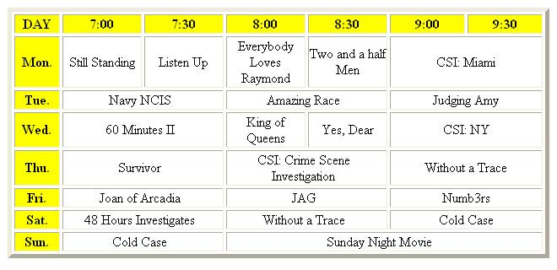
To create the television schedule table-

- In your text editor, create the TVList.htm file and save to your H: drive
- Create a table that has seven columns and eight rows, one of the rows consisting of table headers.
- Set the table border width to 5 pixels, the cell spacing to 3 pixels, and the cell padding to 5 pixels.
- Set the width of each cell in the first column to 50 pixels. Days of the week should be bold and aligned left.
- Set the width of the table header cells (aside from the first column) to 90 pixels.
- Enter the table text. You can find this week's lineup at http://www.khou.com/
- Create spanning cells as indicated in Figure 463. 8. For each half-hour program, set the cell width to 90 pixels; set the cell width of hour programs to 180 pixels, of two-hour programs to 360 pixels, and of three-hour programs to 540 pixels.
- Set the background color of the first row and first column of the table to yellow.
- Center the table on the page.
- Save your changes to the file.
- View the page in your web browser.

